**GITHUB**

**https://github.com/pricing**

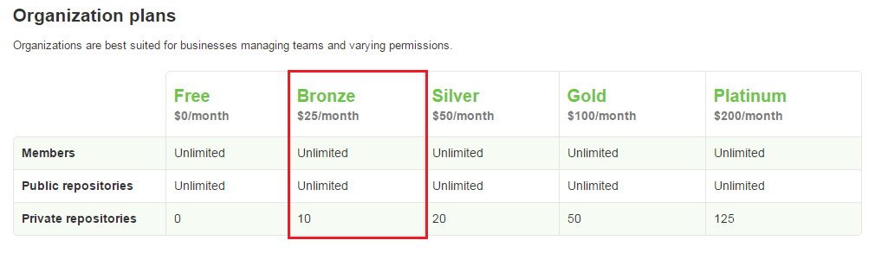

**PHPSTORM**

**https://www.jetbrains.com/phpstorm/buy/**

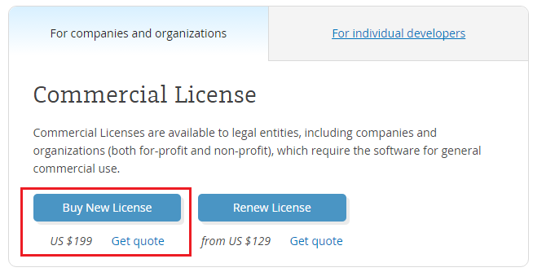

**CLEANZONE**

**https://wrapbootstrap.com/theme/clean-zone-responsive-admin-template-WB00XNXM0**

